

**ROOM AUTOMATION**

1) Priyanshu Modi

2) Moinuddin Chippa

3) Abhinav Kabra

4) Rahul Kumar (Team Leader)

Under Graduate Students, Department of Information Technology, Government College of Engineering, Ajmer,

Rajasthan, India

**ABSTRACT:** The core of this paper is to develop a system which will make a step for the energy conservation. Energy conservation refers to reducing of energy consumption through using less of an energy service. This system consists of controlling of two different systems i.e. one is the street lights and another is the pump through which the level of the tank will be controlled automatically. Another system this paper is going to propose is the security system which is used on the main entrance gate, for the visual presentation of the system a prototype of the college campus is made. The controller used in the system is Arduino Uno. The interfacing of the system with Arduino is very much easy and works successfully. Arduino increases the responsiveness of the system. The main objective of this system is to reduce the power consumption due to wastage of street lights, increase the security of the campus and to control the water level of the tank.

**I. INTRODUCTION**

Electronic and Electrical environment with respect to this context is any environment which consists of appliances such as street lights, water level control, security alarm etc. A remotely accessible environment is an environment in which each appliance can be accessed automatically and controlled using software as an interface, which includes a Programming and web application. Such remotely accessible systems are already available in the market, but have a number of drawbacks as well. This paper aims to perform a survey of all the existing systems and compare these systems with this system. The paper will also compare and contrast all the systems and look at their various features and disadvantages. A wide variety of options are available for the automation. The system proposed to provides means to control the light of room. The real time monitoring has been an important feature that can be used in the room automation systems. As a change in the status of the devices occurs, the user can be informed in real time. The user commands are transferred to a server which is usually done by indicators. This can help control the devices. Arduino is used as a communication medium to help establish connection. The system makes use of a Arduino for room light control.

**II. LITERATURE REVIEW**

In this section, discussed different Room Automation System with their technology with features, benefit and limitations they have. Controlling lighting system by means of LDR and Arduino together is relatively a new concept. Some were controlled by wireless GSM/GUI networks. That being said they are no papers which coin all the lighting system under one umbrella and use LDR and Arduino system as their fundamental architecture to control it. Ancient Lighting system have been This kind of operation

meant energy loss due to continuous operation at maximum voltage though actual requirement might be less depending upon the outside lighting condition. The simplest solution to it is by calibrating the lights according to the room lighting condition. This is what the paper aiming for in our smart lighting system.

**III. CIRCUIT COMPONENTS**

All the circuit component we are using in our project are described below.

Components Specifications

* Arduino Uno R3
* Motion sensor (PIR sensor)
* Light bulb
* Photoresistor
* Kohm Resistor
* (0.6) amperes ,7.19999 volts power supply

A. Light Bulb

An incandescent light bulb, incandescent lamp or incandescent light globe is an electric light with a wire filament heated until it glows. The filament is enclosed in a bulb to protect the filament from oxidation. Current is supplied to the filament by terminals or wires embedded in the glass. A bulb socket provides mechanical support and electrical connections.

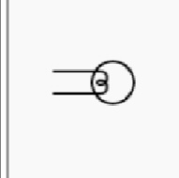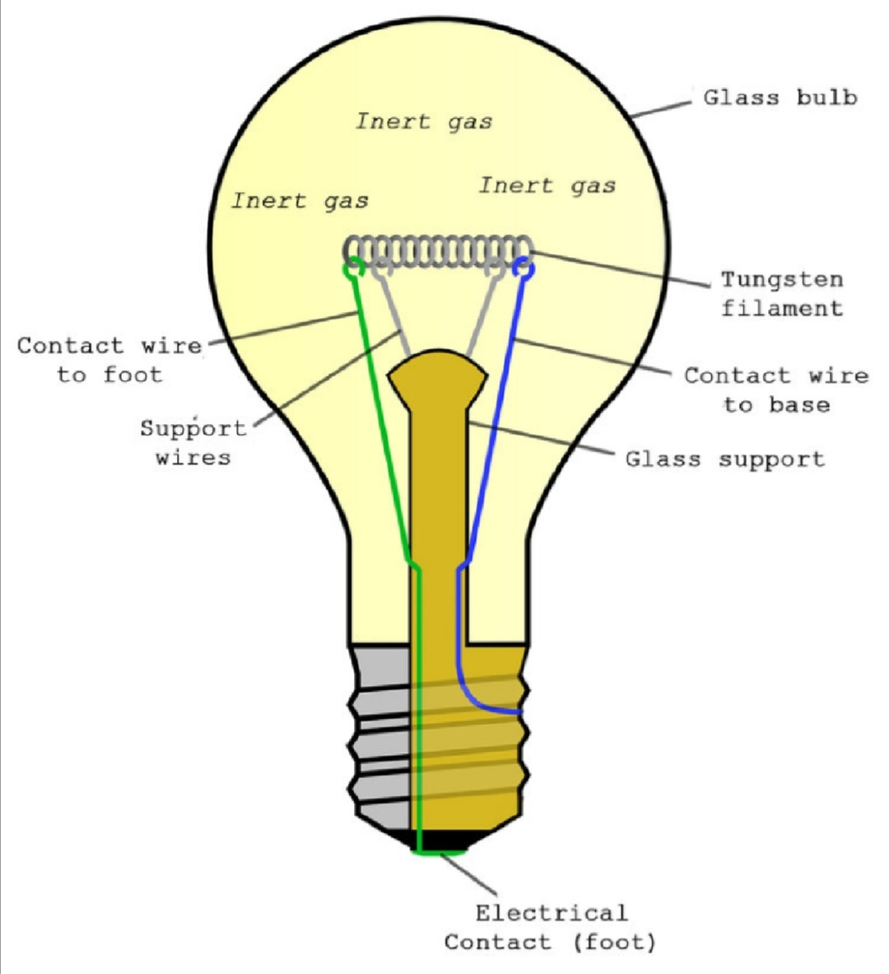

1. Symbol b) basic structure

Fig. 1. Light bulb symbol & working

B. PIR Sensor

An infrared sensor is an electronic instrument which is used to sense certain characteristics of its surroundings by

either emitting and/or detecting infrared radiation. Infrared sensors are also capable of measuring the heat being emitted

by an object and detecting motion.

C. Arduino Uno

Arduino is an open-source physical platform based on microcontroller board having the ATmega32 series controllers and Integrated Development Environment for writing and uploading codes to the microcontroller. It has input and output pins for interaction with the outside world such as with sensors, switches, motors and so on. To be precise it has 14 digital input/output pins (of which 6 can be used as PWM outputs), 6 Analog inputs, a 16 MHz quartz crystal, a USB connection, a power jack, an ICSP header and a reset button. It contains everything needed to support the microcontroller.

It can take supply through USB or we can power it with an AC-to-DC adapter or a battery Arduino acts as the

processing module of the system. It takes input from the LDR, process the data and gives the output to LEDS directly

or through a relay and a transistor mechanism.

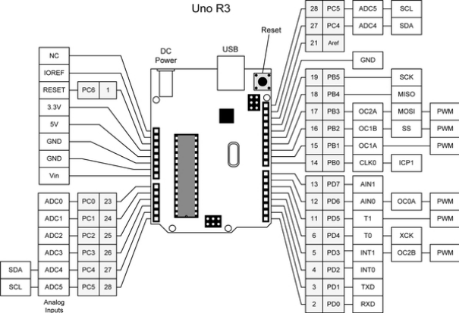

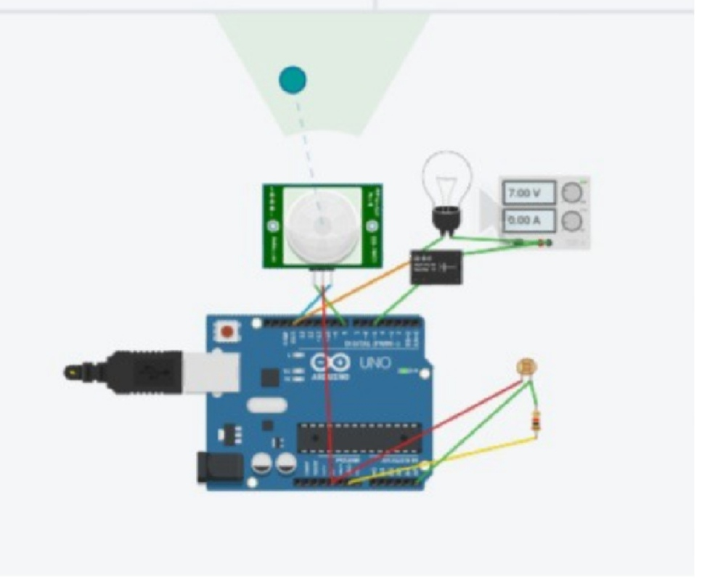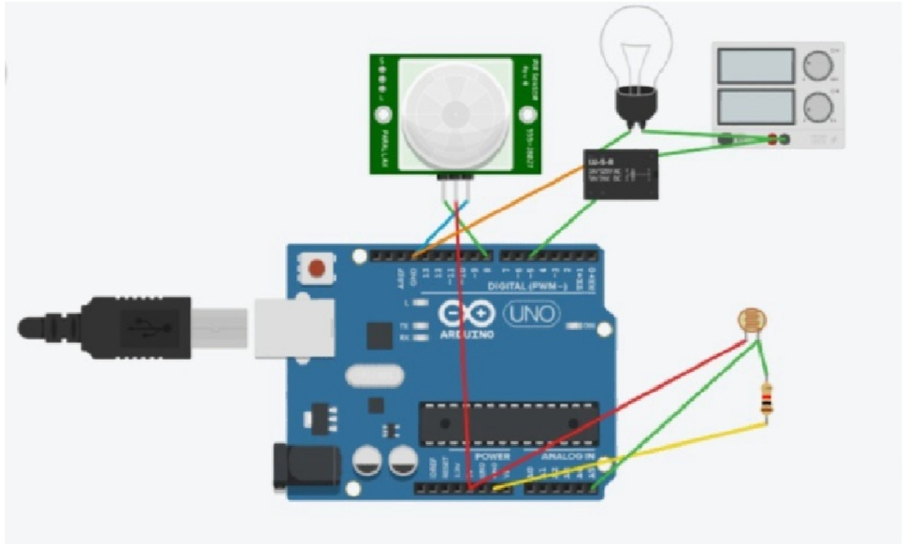

Fig. 2. Working of PIR sensor with Arduino

C. Photoresistor

A photoresistor is a passive component that decreases resistance with respect to receiving luminosity on the component's sensitive surface. The resistance of a photoresistor decreases with increase in incident light intensity; in other words, it exhibits photoconductivity

**IV. WORKING PRINCIPLE OF ROOM LIGHTS**

Light bulb has the property to change its resistance according to the intensity of light. When a light of high intensity falls on bulb its resistance decreases and when it goes below our set point value our controller switches ’OFF’ the light. When the intensity of light decreases the resistance increases and when it crosses the set point value our controller switches the light ’ON’. In this way our system works as automatic street light control. Which is very energy efficient in further topic we told how much we save from this system

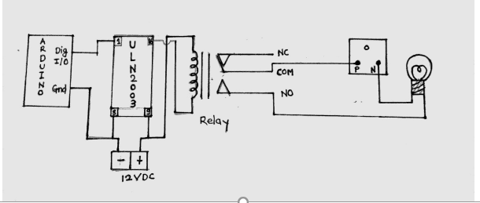

Fig. 3. Circuit diagram for actual model using relay and ULN2003

The above circuit is the actual circuit which should be implemented for controlling the 230V AC lights. The figure shows that the digital output of Arduino is connected to pin no. 1 of ULN2003 IC and ground of both Arduino and ULN are shorted. The 12V supply is required for controlling the relay which is given through the ULN. And our final control element is connected to the relay through (0.6) amperes ,7.19999 volts.

**VIII. CALCULATIONS**

In this project by automatic room lights we are going to save lot much of energy per day. By saving energy we are stepping forward to our country’s development.

If we assume only more two hours our lights will be kept ’ON’ one hour in morning and one hour in evening then the energy wasted will be 40 KWH per DAY.

**IX. CONCLUSION AND FUTURE SCOPE**

Advantages of proposed system on current system

1. There is no need of any manual operator as the system is fully automatic.

2. Switching time changes according to the climate.

3. Energy is Conserved. However, with the help of this system we will conserve energy which indirectly leads us country to the development.